Responsible Innovation Stories – Join the debate with leading scientists and successful managers

Today’s complex challenges such as climate change, ageing populations and digitization require a closer collaboration between academia and industry. These wicked problems fundamentally transform individual businesses, disrupt entire sectors and demand innovative research solutions. Emerging technologies such as Artificial Intelligence, Internet of Things and Augmented Reality hold unprecedented potential to alleviate some of these issues – e.g. smart homes and cities promise to create efficient energy management, robotics and tele-medicine may revolutionize our health care systems. However, some of these turning-point technologies may create unintended side-consequences, as we have seen in the case of GMOs or nuclear research.

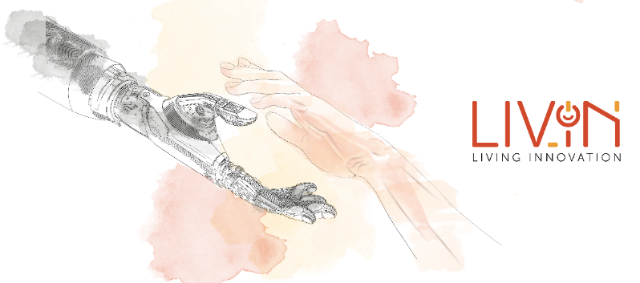
To develop more responsible approaches to innovation, the LIVING INNOVATION project brings together a plethora of stakeholders from academia, industry and civil society. It provides a central knowledge hub and unique meeting point for experts and practitioners in digitization and responsibility.

To provide a concise and compelling entry point to Responsible Innovation, the project hosts “Responsible Innovation Stories”. This weekly interview series features inspiring ideas, great thinkers and flagship initiatives such as:
- Responsibility and transformational change in innovation systems – René von Schomberg (EU Commission), on his ground-breaking conceptualization of Responsible Innovation
- Ethics and responsible innovation in EU projects and the dire need to assess impacts of big tech – David Coles (impact assessment pioneer and Director Enhance International)
- The do's and don'ts of successful industry-academia collaborations (forthcoming) – Tima Bansal (Ivey Business School)

Over the last few weeks, dozens of scholars and managers have launched joint actions to:
- Explore the business case for responsible innovation
- Try out responsible innovation tools
- Benchmark their responsible innovation maturity

Join this highly relevant community of experts and increase the societal contribution of academia: http://www.living-innovation.net/signup
Responsible Innovation - Business Opportunities and Strategies for Implementation
Katharina Jarmai, WU Vienna
https://www.springer.com/gp/book/9789402417197#aboutBook
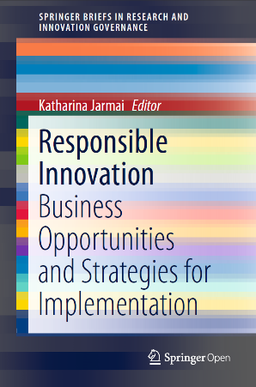
Responsible innovation provides benefits for society, for instance more sustainable products, more engagement with consumers and less anxiety about emerging technologies. As a governance tool it is mostly driven by research funders, including the European Commission, under the term “responsible research and innovation” (RRI). To achieve uptake in private industry is a challenge. This book provides successful case studies for the implementation of responsible innovation in businesses. The importance of social innovations is emphasized as a link between benefits for society and profits for businesses, especially SMEs. For corporate industry it is shown how responsible innovation can offer a competitive advantage to adopters. The book is based on the latest insights from theory and practice and combines conceptual work with first-hand experience. It is of interest to innovation managers, entrepreneurs and academics.
For academics, the book will provide a combination of analysis and discussion, and present recent learnings from first-hand interaction with entrepreneurs. For innovation managers and entrepreneurs, it will provide inspiration and better ideas about what responsible innovation can look like in practice, why others have “done it” and what the potential benefits might be. The book will thus serve the purposes of spreading the word about the responsible innovation concept among different audiences whilst making it more accessible to innovation managers and entrepreneurs.

