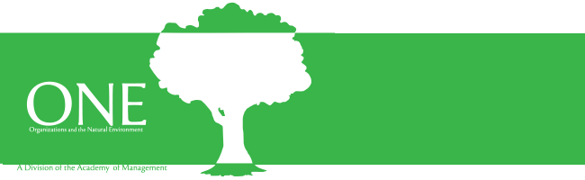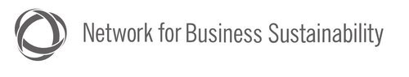

2022 ONE and Network for Business Sustainability (NBS)
Research Impact on Practice Award

This award recognizes a piece of contemporary, peer-reviewed research that has important implications for practice. The research may focus on any issue that is of societal or environmental importance. The Network for Business Sustainability (NBS) co-sponsors this award with the Organizations and the Natural Environment Division.

The winner will receive $500 cash and a trophy. The research will be promoted through NBS’s international network of business leaders, researchers, and students (see description of NBS at end of document).

Find out about previous award winners here: https://www.nbs.net/articles/r-research-impact-on-practice-award-winners

Nomination and evaluation

The paper must be published during the previous calendar year (January 1-December 31, 2021) either a) online (must have a DOI number) or b) in hard copy. However, any single paper can only be nominated once (i.e. a paper published online one year cannot be nominated again when it appears in the journal).

At least one author needs to be an ONE Division member.

Applicants may nominate their own work or the work of another.

To nominate an article, submit the original article, along with a letter of nomination, which should include:
- Full citation and author’s contact information
- Description of the key contributions (theoretical and empirical) (max 150 words)
- Description of the realized or potential implications for practice (max 150 words)

The descriptions should be written in language that is accessible to knowledgeable sustainability practitioners.

The criteria for judging articles are:
- Relevance (e.g. is the topic of importance to managers or other practitioners) (50%)
- Rigor (i.e. what is the quality of the research — the work must be empirical, but can be based on qualitative or quantitative data) (50%)

We also encourage members of the research community to join NBS to share insights with practitioners.

The submission deadline is April 30, 2022. Please send submissions, and any questions, to both Maya Fischhoff of NBS (mfischhoff@nbs.net) and Natalia Ortiz de Mandojana, ONE Awards Committee (nortiz@ugr.es)

The judging committee will consist of an ONE Awards Committee member, an additional ONE member (appointed by the ONE Awards Committee Chair), one NBS staff person and a member of the practitioner community (e.g. sustainability managers).

The winning paper will be announced at the ONE Division business meeting in August.

About NBS

The Network for Business Sustainability (NBS) is dedicated to making business more sustainable. We do this by sharing evidence-based guidance for business leaders thinking ahead. Over 35,000 business leaders, researchers and students from around the world contribute to and follow our work. We also facilitate a community of 200 sustainability research centres. NBS's main office is at the Ivey Business School (Canada), with a francophone office at L’Université du Québec à Montréal. More information at: https://www.nbs.net/

