WHAT CAN CORPORATIONS DO TO HELP
NAVIGATE THE STORM THAT IS COVID-19?

Judith Walls & Steve Walls
25 March 2020

In the last week you’ve probably had the capacity of your e-mail Inbox tested with communication from dozens of businesses, each telling you about their response to the COVID-19 outbreak.

The majority of those messages will have told you to “Stay Home, Stay Safe.”
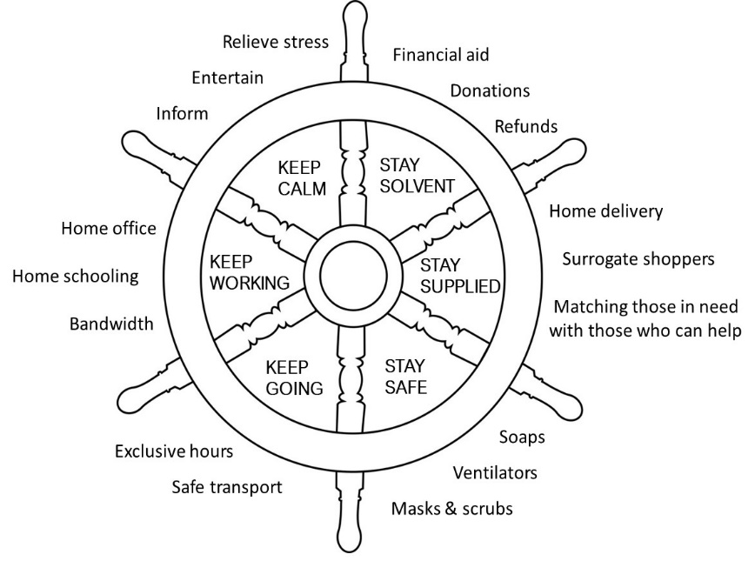
A very small minority will have told you what they’re actually doing to help navigate the storm in a practical way. You might therefore wonder if this is all just another form of symbolic action.
Figure 1: Wheel of Corporate Purpose during Times of Crises

And yet, times of crises are precisely the points when companies can prove their purpose, and their substantive commitment to social and environmental causes.

Here, we provide ideas as to where companies can help at this time of need (Figure 1).

The moto goes: Keep Calm, Keep Working, Keep Going, Stay Solvent, Stay Supplied, and Stay Safe.
Keep Calm
Can companies help people remain calm under lockdown?
Can companies help keep stress levels low? Could they provide entertainment to people? Or fact check the stories spreading on social media? Or, bring people together through interactive sessions aimed at providing exercise, blowing off steam or just breathing deeper?

To date, the “keep calm” strategy has been left to individuals who set up Facebook help groups, art institutions offering virtual museum tours, or stunt offers like free premium Pornhub. But, could for example, Amazon stream entertainment from artists who lack stages to perform on and have lost all their income? Or could a mental health company balance to off-kilter kids?

Keep Working
Can companies make home offices run smoothly and make home schooling a reality?
Are companies willing to offer people access to more bandwidth, programs, and data? Are they prepared to scale up their helplines? Will they collaborate with competitors to offer the best ‘Home Office’ and ‘Home Schooling’ tools for customers?
To date, companies like Zoom and Microsoft (MS-Teams) are providing virtual platforms for work meetings, university lectures and grade school teachers. Netflix has stepped in to create more bandwidth by (slightly) lowering the quality of streamed movies and programs. But more can be done to ensure that social distancing doesn’t become total isolation.

Keep Going
Can companies support the people on the frontlines?
Will companies extend shopping hours so that doctors and nurses can look after their families too? Can they help find ways to get them to and from work more safely?
Supermarkets like Tesco have been quick to offer exclusive shopping hours to emergency service providers and to senior citizens, but there’s room to further safeguard their safety both at work and on their commutes.
Stay Solvent
Can companies help people stay financially afloat while they weather the storm?
Are companies prepared to give people refunds on lost holidays? To waive late fees? To extend overdraft facilities? To give discounts on essential items? Will companies financially support foodbanks and offer free financial information helplines?
We’ve seen telco providers and some banks step up to offer help with repayments, but more can be done. Financial support for NGOs and charities dedicated to feeding the poor hasn’t really started to pour in. Supermarkets and restaurant chains could offer produce, manpower and financial support to ready these organizations for a flood of fresh demand.

Stay Supplied
Can companies ensure that the old and vulnerable isolated at home can get food and medication?
Can companies provide the logistics to deliver medicines to people who can’t go out to pick them up? Can they provide transport for the compromised to travel safely to essential places? Can they provide technology to connect the mobile and strong with the isolated?
To date tech companies and app providers have been very slow to try to match those in need with those that can help. This is an area where dating apps could lend a hand, an algorithm or a user interface, bringing together those who can offer help with those who need it.

Stay Safe
Can companies provide the essentials to stop / slow the spread of COVID-19?
How much of a company’s production can be switched to make essential items like soaps, masks and ventilators needed to stop the spread of the virus? Are companies willing to abandon their key business lines temporarily?

This is the most obvious, immediate way that some companies can help, so it’s heartening to see those who can manufacture at scale stepping into the fray. Tesla is providing masks and plans to manufacture ventilators. Ford is also onboard. LVMH is making hand sanitizers. Zara has committed to sewing masks and scrubs as protective gear for hospital workers.
In short, the world is in need of real help to navigate this crisis and too many companies are responding with clever brand or logo treatments.
It’s time for companies to more than talk. It’s time for them to walk. They can do so by closing the gap between symbolic and substantive action and live up to their purpose rhetoric.

