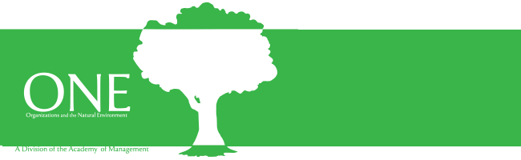

2024 Organizations and Natural Environment (ONE) Division
Book Award: Call for Nominations

The Organizations and the Natural Environment (ONE) Division of the Academy of Management 2024 Book Award recognizes the best book published in the previous three years (2021, 2022 or 2023) in the area of organizations and the natural environment.

KEY INFORMATION

- The recipient will receive an award plaque from ONE, a check for $500 from the ONE division and award sponsor, recognition at the annual AoM ONE Business Meeting (where the recipient of the award will be announced), as well as a listing with past Book Award winners on the ONE website.
- At least one author (or editor for collected works) needs to be ONE member.
- Edited books (books divided into chapters, each written by a different author or group of authors) are eligible for the ONE Book Award so long as they have a research focus in the ONE field and have a value-added overview chapter by the editors.
- New editions of previously published works, while laudable, are not eligible for the ONE Book Award.

NOMINATION PROCESS

- Nominations by others and self-nominations are possible. Stage of career and background do not matter, so long as the member is in good standing at the Academy of Management.
- The nomination should be in the form of a brief supporting statement summarizing the book and explaining how the book addresses organizations and the natural environment topics.
- The nomination statement should be addressed by email to Jorge Rivera (jrivera@email.gwu.edu), Chang Hoon Oh (changhoon_oh@ku.edu), and Jennifer Oetzel (oetzelj@american.edu), ONE Book Award Committee Co-Chairs.
- The nominator or nominee should send (or request the publisher to send) a copy of the nominated title to each member of the book award committee. Please contact the Co-Chairs for a list of addresses. If you send an eBook, please send a copy to the Co-Chairs for distribution to committee members (it will not be distributed further than needed for the award evaluation process).
- The nomination statement deadline is April 30, 2024. Books should be received soon after.

SELECTION CRITERIA

Nominated books will be judged according to five criteria:

- Originality in substance and approach
- Significance for scholarly and/or policy debate in the field
- Potential for applied impact
- Rigor in approach and analysis
- Readability

2024 ONE Book Award Committee Members

- Jorge Rivera
- Chang Hoon Oh
- Jennifer Oetzel

If you have any questions or require further information, please contact Jorge Rivera (jrivera@email.gwu.edu), Chang Hoon Oh (changhoon_oh@ku.edu), and Jennifer Oetzel (oetzelj@american.edu).

Thank you for your interest, and we look forward to receiving your nomination!

Jorge Rivera
Chang Hoon Oh
Jennifer Oetzel
ONE Book Award Committee Co-Chairs

