ONE Awards and Recognitions
In this section:

- ONE Dissertation Award
- ONE Best Student Paper Award
- ONE Best Paper Award
- ONE Best Reviewer Award
- ONE and Network for Business Sustainability Research Impact on Practice Award
- ONE-SIM Outreach Award
- ONE Book Award
- ONE Teaching Award
- ONE Emerging Scholar Award
- ONE Best Paper in Entrepreneurship and Natural Environment
- ONE Outstanding Service Award
- ONE Distinguished Scholar Award
- Other awards and recognitions awarded to ONE members

Join us in congratulating the recipients (and runners-up) of the ONE Division 2022 Awards!

Award Team: Natalia Ortiz-de-Mandojana, Tracy Van Holt, Elisa Alt
Click here for a spreadsheet of all past ONE award winners.

ONE Dissertation Award

Award Committee:
Katrin Heucher – Chair (University of Michigan Erb Institute for Global Sustainable Enterprise); Pilar Acosta (École Polytechnique); Maoliang Bu (Nanjing University); Björn Mitzinneck (University of Groningen)

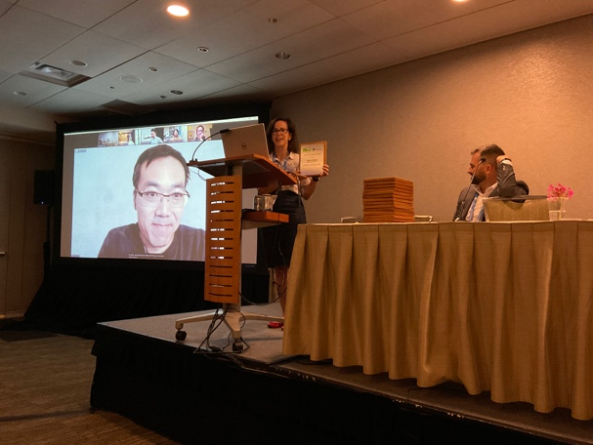
WINNER:
Kevin Chuah
(London Business School)
Collective action for sustainability: The role of investor coalitions in external corporate governance

RUNNER-UP:
Haitao Yu
(Ivey Business School)
Organizing and sustainable development between the local and global: The case of a Tibetan enterprise

ONE Best Student Paper Award
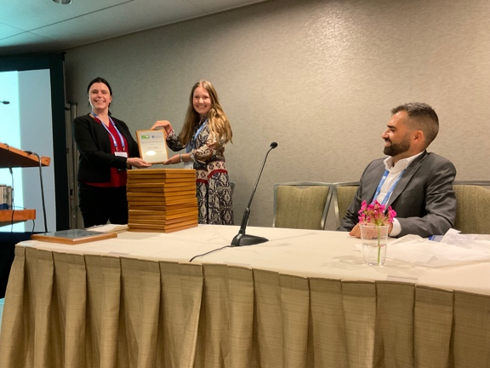
WINNER:
Anne Kellers, Julian Fritz Kölbel (U. of Zurich), & Falko Paetzold (EBS U. of Business and Law)
Investors pushing for sustainability: How firms assess the authenticity of investors’ ESG requests

ONE Best Paper Award
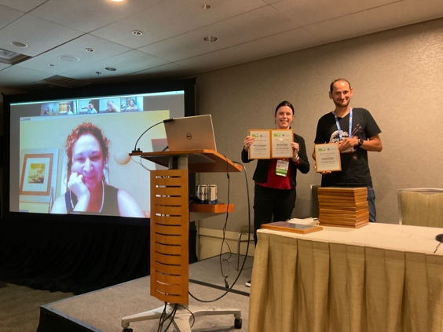
WINNER:
Mercedes Bleda, Jonatan Pinkse, & Eleni Christodoulou (U. of Manchester)
The role of emotions and cognitive biases in business adaptation to climate change

ONE Best Reviewer Award

Award process led by: Martina K. Linnenluecke (Chair), ONE Program Team
Anifowose, Princess (The Open U. Business School)
Bender, Rahmin (Wageningen U. and Research)
Bidmon, Christina (Utrecht U.)
Boe-Lillegraven, Siri Nordland (U. of Amsterdam)
Bond, Carol J. (RMIT U.)
Borsa, Zsuzsa (U. of St. Gallen)
Brammer, Stephen (U. of Bath)
Braun, Sophia (ESCP Business School)
Carmine, Simone (U. of Padova)
Chuah, Kevin (London Business School)
Dahlmann, Frederik (U. of Warwick)
Dordi, Truzaar (U. of Waterloo)
Dowbiggin, Anna (U. Of Guelph-Humber)
Flowers, Mallory Elise (U. of Rhode Island)
Good, Jason (Amsterdam School of International Business)
Grüll, Anja (WU Vienna U.)
Heikkinen, Anna (Tampere U.)
Henriques, Irene (York U.)
Hofstetter, Joerg S. (Kedge Business School)
Joo, Youngbin (U. of Leeds)
Keller, Carina (EBS U. für Wirtschaft und Recht)
Meissner, Katie (U. of Queensland)
Montgomery, A. Wren (Ivey Business School)
Nava, Lucrezia (Cambridge Judge Business School)
Nichols, Elizabeth (Christian Heritage College)
O'Flanagan, Sinead (Higher Education Authority, Ireland)
Ortiz, Daniela (FHWien der WKW U.)
Park, Junghoon (Baruch College & The Graduate Center, CUNY)
Pinkse, Jonatan (U. of Manchester)
Pisciella, Arianna (U. of Lausanne)
Poggioli, Nicholas (Appalachian State University)
Rands, Gordon P. (Western Illinois U.)
Rashidi, Kamran (BTECH Aarhus U.)
Reinecke, Pauline Charlotte (Hamburg U. of Technology)
Sartoris, Costanza ( U. Ca' Foscari of Venice )
Spraul, Katharina Stefanie (Technische U. Kaiserslautern)
Su, Janet (U. of Lausanne)
Unter, Kerrigan Marie Machado (George Washington U.)

See a list of past Best Reviewer Awards Recipients here: https://drive.google.com/open?id=1cuGx9WcYnHaCvPJDJGh05TDILFOCHKHd

Thanks Nicholas Poggioli for putting it together, and don’t forget to register as a reviewer for the next AOM!

ONE and Network for Business Sustainability Research Impact on Practice Award

Award Committee:
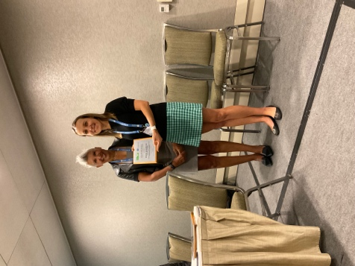
Maya Fischoff – Chair (Network for Business Sustainability); Daniel Armanios (U. of Oxford), Stephanie Meital; Natalia Ortiz-de-Mandojana(U. of Granada)
WINNER:

Eun Su Lee (U. of Newcastle), & Betina Szkudlarek (U. of Sydney)
Refugee employment support: The HRM–CSR nexus and stakeholder co‐dependency

ONE-SIM Outreach Award

Award coordinators:
Maggie Cascadden (University of Alberta); Emilio Marti (Rotterdam School of Management)

Pre-selection jury:
Grace Augustine – Chair (University of Bath); Ali Gümüsay (Humboldt Institute for Internet & Society Berlin); Garima Sharma (American University)

Jury:
Jerry Davis (University of Michigan); Magali Delmas (University of California, LA); Ioannis Ioannou – Chair (London Business School)

WINNER:

Mark DesJardine (Pennsylvania State University), & Rodolphe Durand (HEC Paris)
For their outreach activities based on the paper “Disentangling the effects of hedge fund activism on firm financial and social performance” (Strategic Management Journal, 2020)
RUNNERS-UP:

Dror Etzion (McGill University), Emmanuel Kypraios (Maynooth University), & Bernard Forgues (EMLYON Business School)
For their outreach activities based on the paper “Employing finance in pursuit of the sustainable development goals: The promise and perils of catastrophe bonds” (Academy of Management Discoveries, 2019)
ONE Book Award

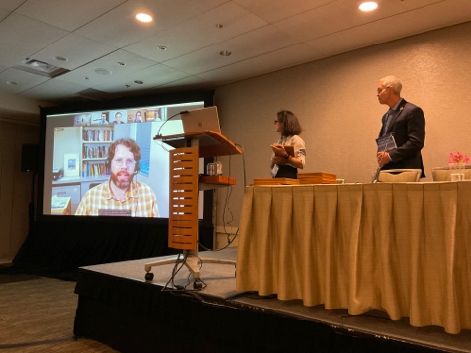
Award Committee:
Janina Grabs – Chair (ESADE), Domenico Dentoni (Montpellier Business School); Nicholas Poggioli (Appalachian State University); Maja Tampe (ESADE)

WINNER:
Robert Sroufe (Duquesne University), Craig Stevenson, & Beth Eckenrode (AUROS Group)
The power of existing buildings: Save money, improve health and reduce environmental impacts
ONE Teaching Award

Award Committee:
Nancy E. Landrum – Chair (Loyola University Chicago); Stuart Allen (Robert Morris University); Shelley F. Mitchell (Hult International Business School); Sukhbir Sandhu (University of South Australia); Rae Andre (Northeastern University)

WINNER:
Christopher Craig
(Murray State University)

ONE Emerging Scholar Award

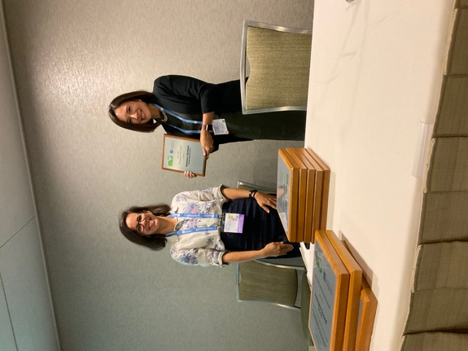
Award Committee:
Mark DesJardine (Chair) (Pennsylvania State University); Caroline Flammer (Columbia University); Olga Hawn (University of North Carolina Chapel Hill); Emilio Marti (Erasmus University Rotterdam)

WINNER:
Vanessa C. Burbano
(Columbia Business School)

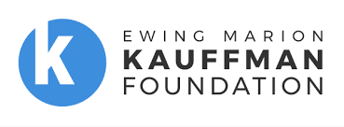
ONE Best Paper in Entrepreneurship and Natural Environment

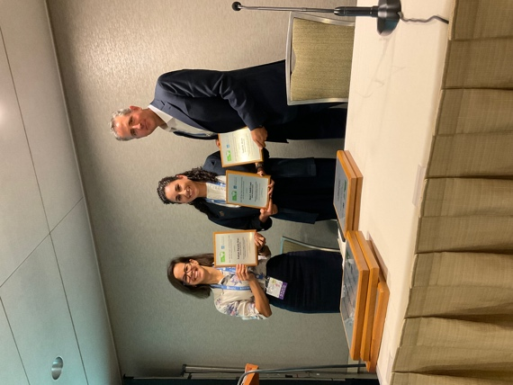
Award Committee:
Jonatan Pinkse (U. of Manchester); Joel Gehman (George Washington U.); Lisa Hehenberger (ESADE)
WINNER:
Todd W. Moss (Syracuse University), Ana C. Dahik Loor (IPADE Business School), & F. Diaz Parada (Syracuse University)
Partnerships as an enabler of resourcefulness in generating sustainable outcomes

ONE Outstanding Service Award

WINNER:
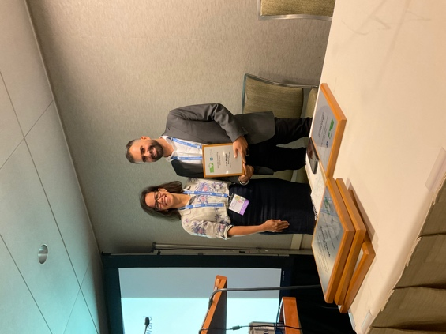
Ivan Montiel
(Baruch College)

Thank you, on behalf of the entire division, for having been such a wonderful Division Chair!

ONE Distinguished Scholar Award

Award Committee:
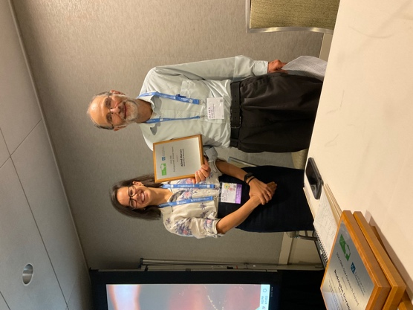
Magali Delmas (University of California, LA), Alberto Aragón Correa (University of Granada) (Co-Chairs), Anne Jacqueminet (Bocconi University)
WINNERS:
Thomas Lyon
(U. of Michigan)

Alfred Marcus
(U. of Minnesota)

Other awards and recognitions awarded to ONE members:

Shout-out to Shon Hiatt (University of Southern California) who won the Best Paper Award, Entrepreneurship Division, for paper entitled: "Stigmatization and immigrant entrepreneurship: Black September, ethnic enclaves, and new venture performance in Jordan"

and

the Responsible Research in Management Award, Academy of Management Fellows with the following paper: Rawhouser H., M. Cummings & S. Hiatt. 2019. "Does a common mechanism engender common results? Sustainable development tradeoffs in the global carbon offset market." Academy of Management Discoveries, 5: 514-529.
Read more in the press release here: https://www.marshall.usc.edu/news/shon-hiatt-paper-wins-top-award

Congratulations to Leandro Nardi (HEC Paris - S&O Institute) and Marieke Huysentruyt who won the Carolyn Dexter Award at AOM 2022 for the paper "Corporate social responsibility, financial materiality, and the challenges of forced migration: Evidence from tragic refugee incidents in Europe."

Leandro Nardi also won the William C. Frederick SIM Best Dissertation Award at AOM 2022.
Shout-out to Cynthia Friedrich (Technische Universität Kaiserslautern) who won the GRONEN Best PhD Student Paper Award: More info here: https://www.linkedin.com/feed/update/urn:li:activity:6940687461073235968

Congratulations to Gorgi Krlev (ESCP Business School, Paris) for winning the Award for impact on German policy in prioritizing social innovation and social entrepreneurship provides lessons for how academics can successfully perform "impact work". Read more here: https://escp.eu/news/gorgi-krlev-wins-istrs-civil-society-impact-research-award

“Accounting for Climate Change” Wins 63rd Annual HBR McKinsey Award (https://www.businesswire.com/news/home/20220412005807/en/“Accounting-for-Climate-Change”-Wins-63rd-Annual-HBR-McKinsey-Award)

